1: question link : <https://leetcode.com/problems/kids-with-the-greatest-number-of-candies/description/>  
  
Solution link : <https://leetcode.com/problems/kids-with-the-greatest-number-of-candies/submissions/1626935839/>

Time Complexity: O(n)   
Space Complexity: O(n)

Screenshot:

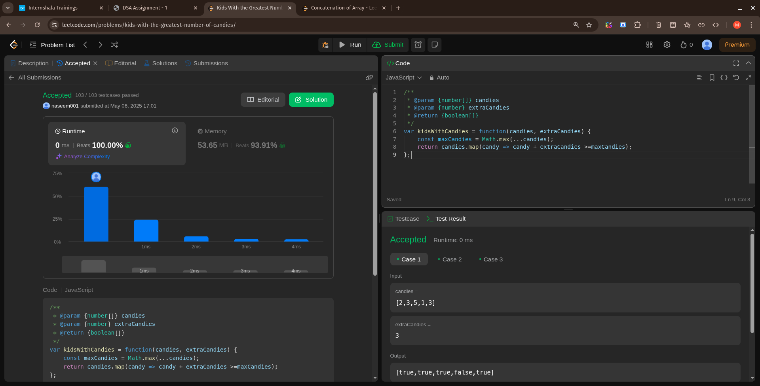

2: question link :

<https://leetcode.com/problems/count-number-of-pairs-with-absolute-difference-k/description/>

Solution link : <https://leetcode.com/problems/count-number-of-pairs-with-absolute-difference-k/submissions/1626946079/>

Time Complexity: O(n^2)   
Space Complexity: O(1)

Screenshot: 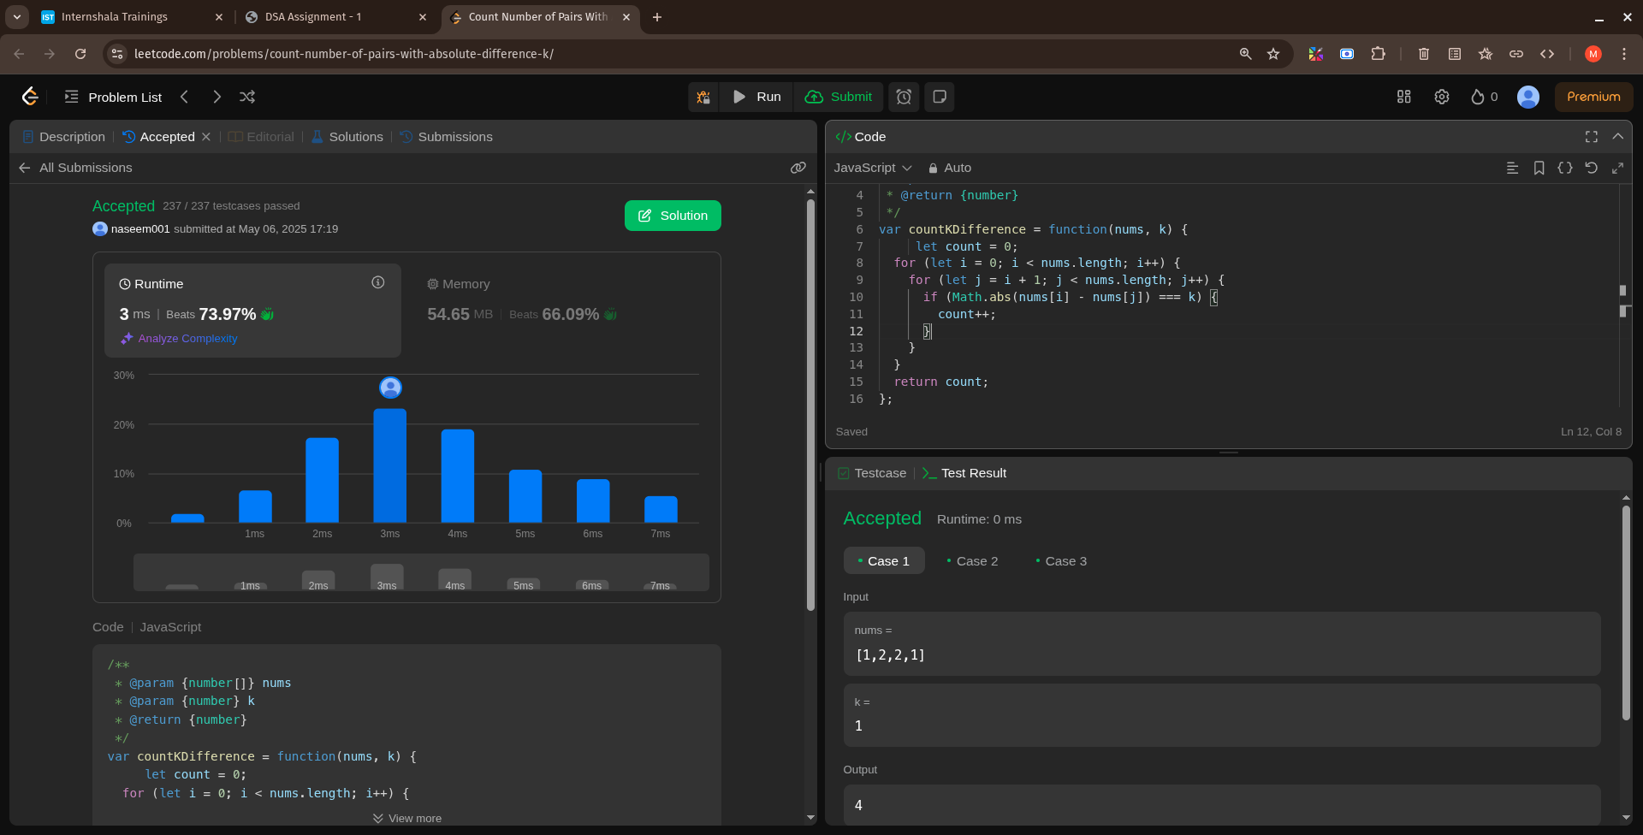

3: question link : <https://leetcode.com/problems/find-common-elements-between-two-arrays/description/>

Solution link : <https://leetcode.com/problems/find-common-elements-between-two-arrays/submissions/1626948694/>  
  
Time Complexity: O(n+m)   
Space Complexity: O(m)

Screenshot:

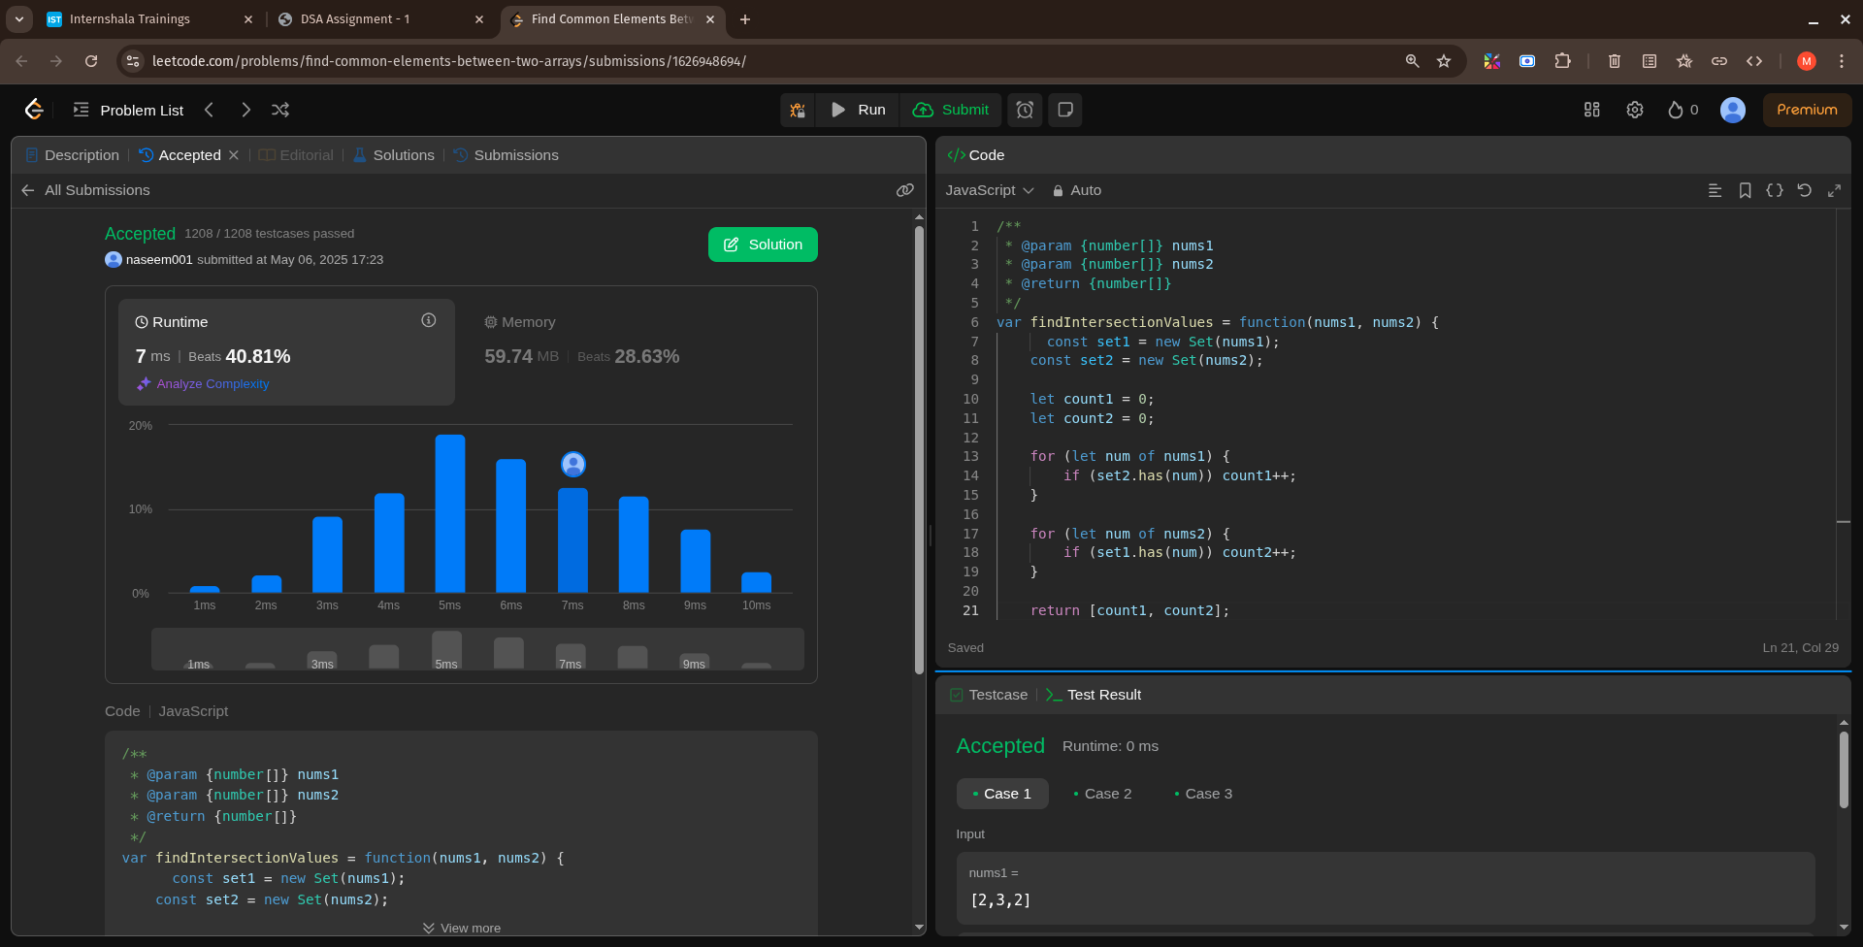

4: question link :

<https://leetcode.com/problems/number-of-good-pairs/description/>

Solution link : <https://leetcode.com/problems/number-of-good-pairs/submissions/1626949750/>

Time Complexity: O(n)   
Space Complexity: O(n)

Screenshot:

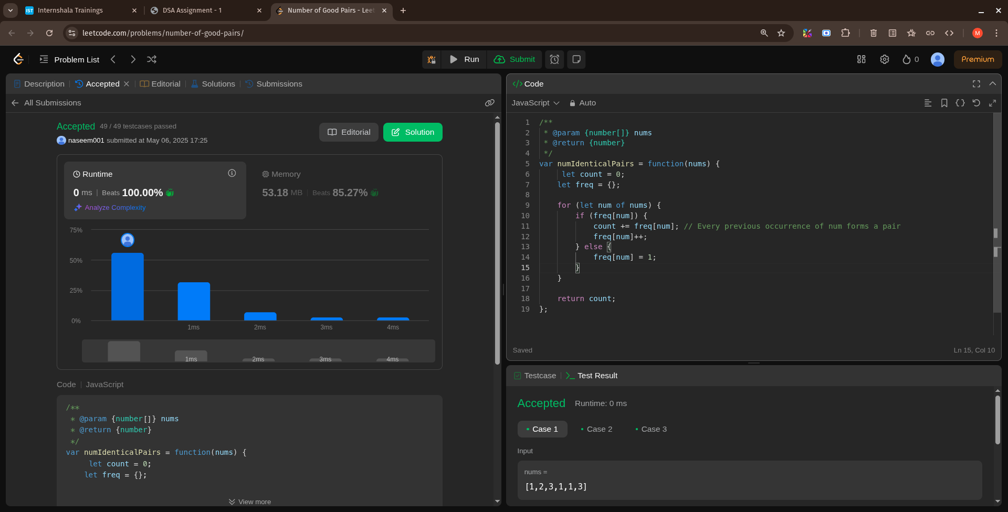

5: question link :

<https://leetcode.com/problems/shuffle-the-array/description/>

Solution link :

<https://leetcode.com/problems/shuffle-the-array/submissions/1626950660/>

Time Complexity: O(n)   
Space Complexity: O(n)

Screenshot:

